Default data

ResNet-18

Best Train accuracy

{

"case": {},

"aggregates": {

"AUC": 0.8411656449668866,

"quadratic_weighted_kappa": 0.7583626695732866

}

}

Validation Loss: 0.6519, Validation Accuracy: 0.7642

Precision: 0.7677, Recall: 0.7642

Confusion Matrix:

Best validation accuracy

{

"case": {},

"aggregates": {

"AUC": 0.8448070126066213,

"quadratic_weighted_kappa": 0.7332556875533816

}

}

Validation Loss: 0.6062, Validation Accuracy: 0.8211

Precision: 0.8434, Recall: 0.8211

Confusion Matrix:

**ResNet-34**

Best train accuracy

{

"case": {},

"aggregates": {

"AUC": 0.826994999194613,

"quadratic_weighted_kappa": 0.7218079395196282

}

}

Validation Loss: 0.6428, Validation Accuracy: 0.7480

Precision: 0.7566, Recall: 0.7480

Confusion Matrix:

Best validation accuracy

{

"case": {},

"aggregates": {

"AUC": 0.8335609091677729,

"quadratic_weighted_kappa": 0.7074309213982319

}

}

Validation Loss: 0.5448, Validation Accuracy: 0.8049

Precision: 0.8048, Recall: 0.8049

Confusion Matrix:

**ResNet-50**

Best train accuracy

{

"case": {},

"aggregates": {

"AUC": 0.8622532075078114,

"quadratic_weighted_kappa": 0.7266403960229424

}

}

Validation Loss: 0.6008, Validation Accuracy: 0.7805

Precision: 0.7801, Recall: 0.7805

Confusion Matrix:

Best validation accuracy

{

"case": {},

"aggregates": {

"AUC": 0.8560228754600118,

"quadratic_weighted_kappa": 0.7051400702187358

}

}

Validation Loss: 0.6019, Validation Accuracy: 0.7967

Precision: 0.7928, Recall: 0.7967

Confusion Matrix:

**ResNet-101**

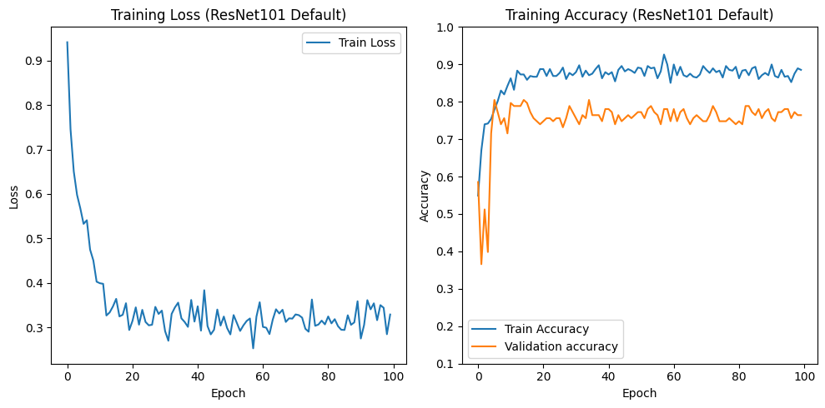

Best train accuracy

{

"case": {},

"aggregates": {

"AUC": 0.8391777893391444,

"quadratic_weighted_kappa": 0.7503614091151183

}

}

Validation Loss: 0.5352, Validation Accuracy: 0.7805

Precision: 0.7853, Recall: 0.7805

Confusion Matrix:

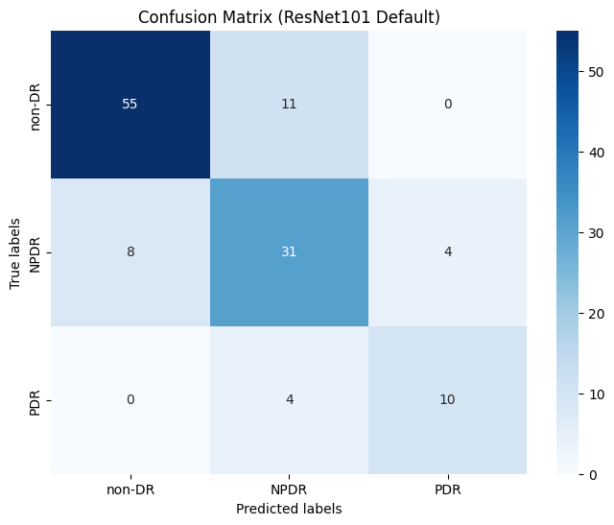

Best validation accuracy

{

"case": {},

"aggregates": {

"AUC": 0.8453629147974592,

"quadratic_weighted_kappa": 0.6899458931486075

}

}

Validation Loss: 0.5610, Validation Accuracy: 0.8049

Precision: 0.8322, Recall: 0.8049

Confusion Matrix:

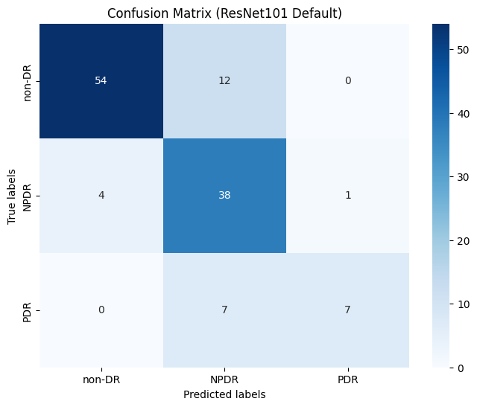

**ResNet-152**

Best train accuracy

{

"case": {},

"aggregates": {

"AUC": 0.8202289767758476,

"quadratic_weighted_kappa": 0.6937048139657909

}

}

Validation Loss: 0.5917, Validation Accuracy: 0.7967

Precision: 0.8068, Recall: 0.7967

Confusion Matrix:

Best validation accuracy

{

"case": {},

"aggregates": {

"AUC": 0.835137276829108,

"quadratic_weighted_kappa": 0.7303200133655321

}

}

Validation Loss: 0.5725, Validation Accuracy: 0.8130

Precision: 0.8170, Recall: 0.8130

Confusion Matrix:

